Samsaran guideline customized for OICT managed services (DSB, DSCS, DSDW)

Contents
Accessing Samsaran 2
Accessing timesheets module in Samsaran 3
1 Create a new timesheet 4
2 Load regular activities from OICT Managed Services 5
3 Load Common Activities (Staff Only) 6
4 Input monthly hours. 7
5 Check Timesheet hours matching Monthly hours (Staff only) 8
6 Register extra hours 8
6.1 Overtime (Staff Only) 8
6.2 Register On-Call and Overtime (Consultants only) 9
7 Confirm and submit monthly timesheet. 11

Accessing Samsaran

Samsaran tool can be accessed from UNICC StaffNet (Quick Links – Samsaran)

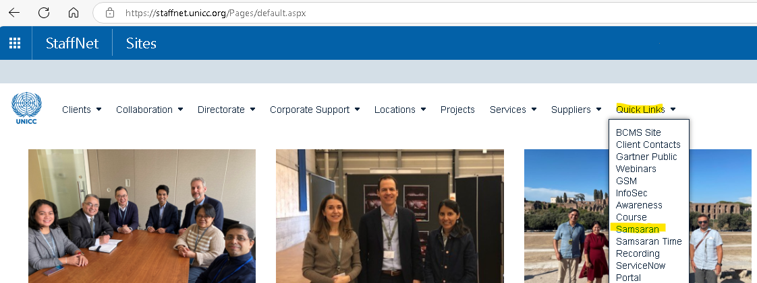

It can be also accessed from the following site: Dashboard -- Finance and Operations

Samsaran main page should be displayed as follows:

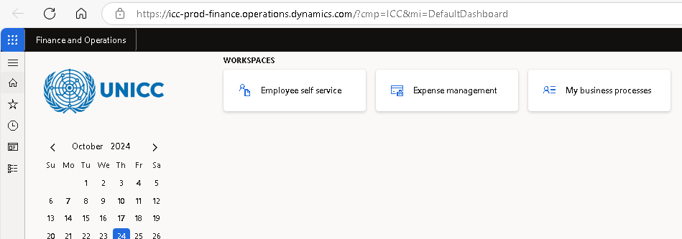

Accessing timesheets module in Samsaran

To access the timesheets module in Samsaran, please use the following path:
Menu - Modules – Project management and accounting – Timesheets – My timesheets

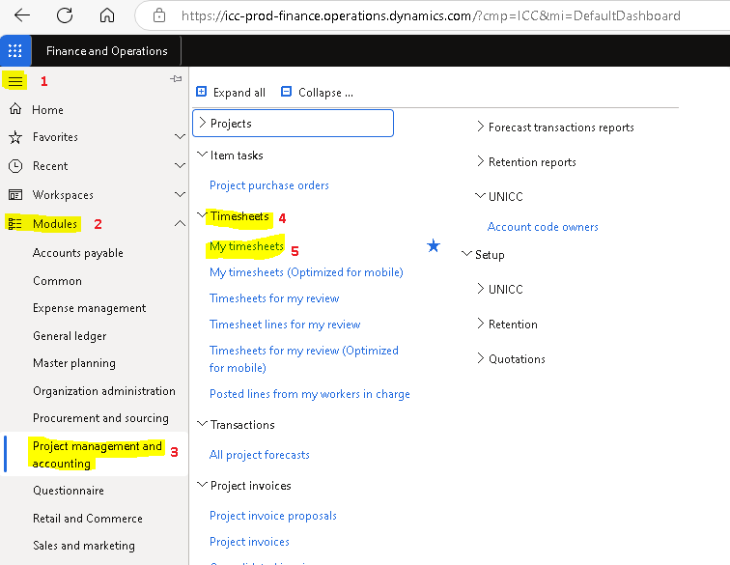

Create a new timesheet

To create a new timesheet, click on “New”.
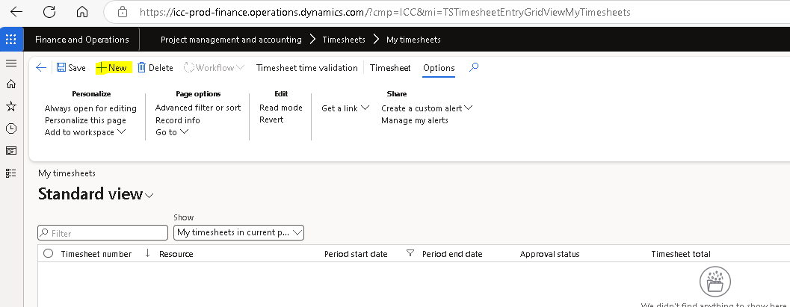

Select any date from the month related to the timesheet and then click “ok”.

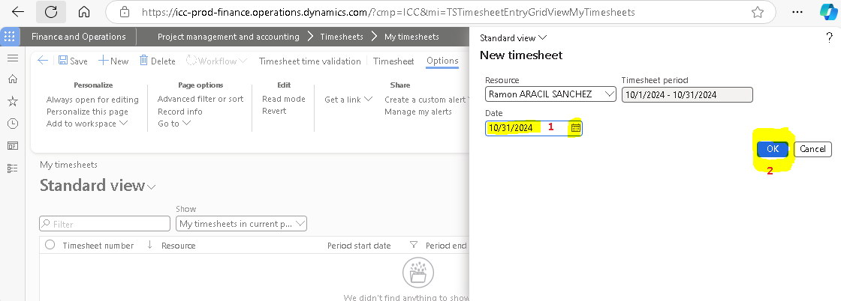

Check that the timesheet has been created as Monthly in “Time input Reference”. Otherwise, escalate to your supervisor. 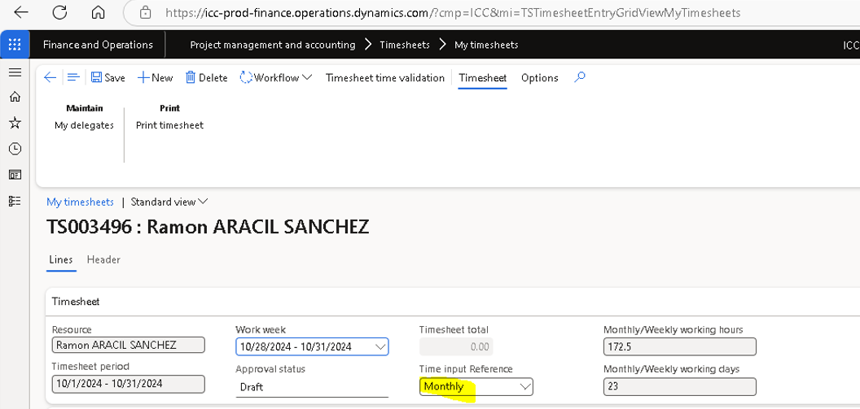

Load regular activities from OICT Managed Services

Click on “Load my activities”.
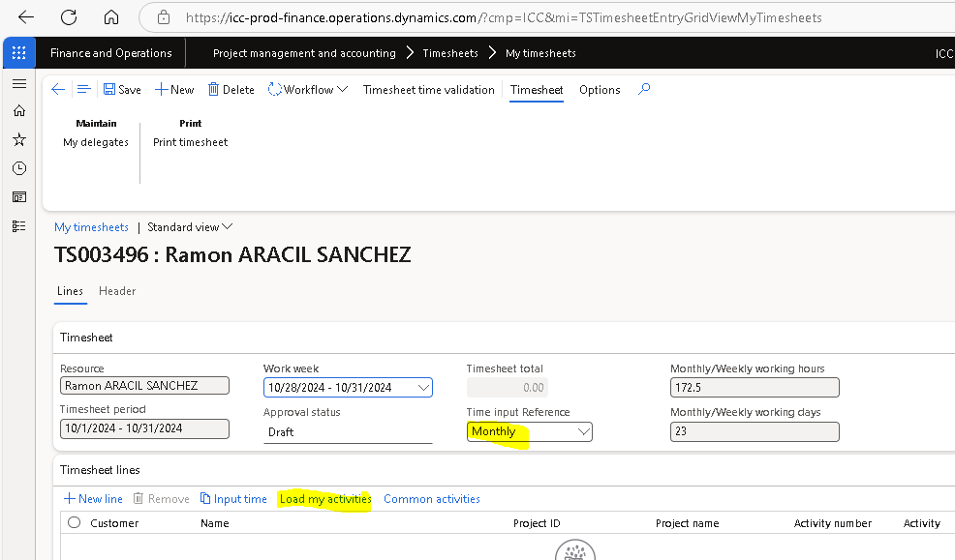

Select the activities that are not required and click on “Remove”.
As a result, we should have at least the one related to OICT - “Office of Information and Communications Technology”, which will be used to register the working hours.

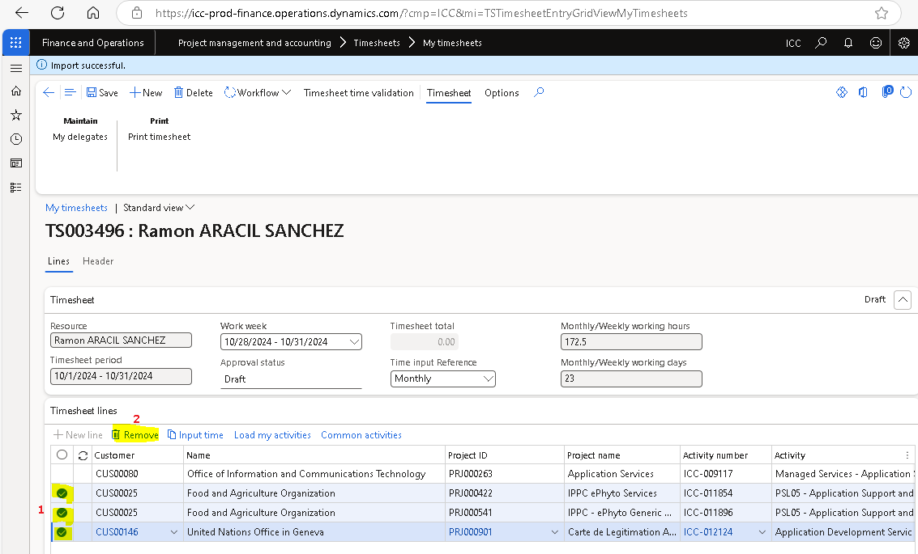

Load Common Activities (Staff Only)

Click on “Common Activities” to register those activities that are not OICT working hours, such as annual leave, other leaves and trainings. Common activities are applicable to staff only.

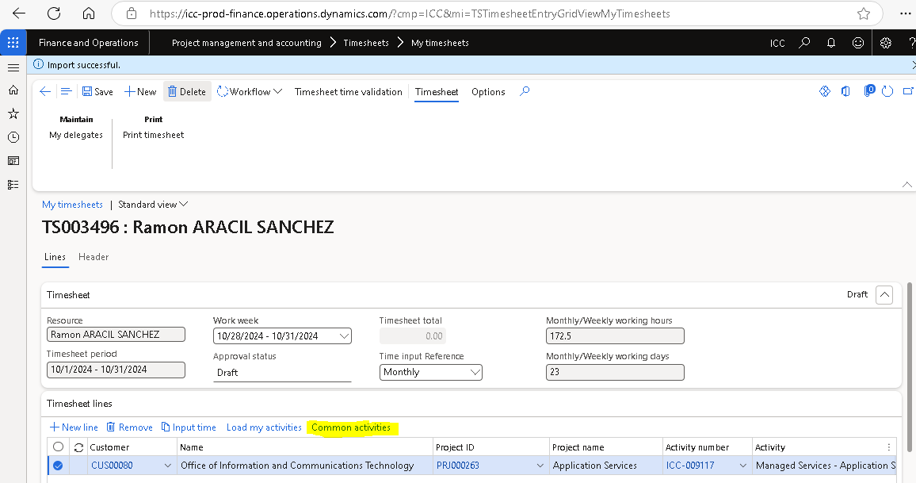

Select the required common activities, for example “Annual leave”. Then click ok.
Common activities are applicable to staff only.

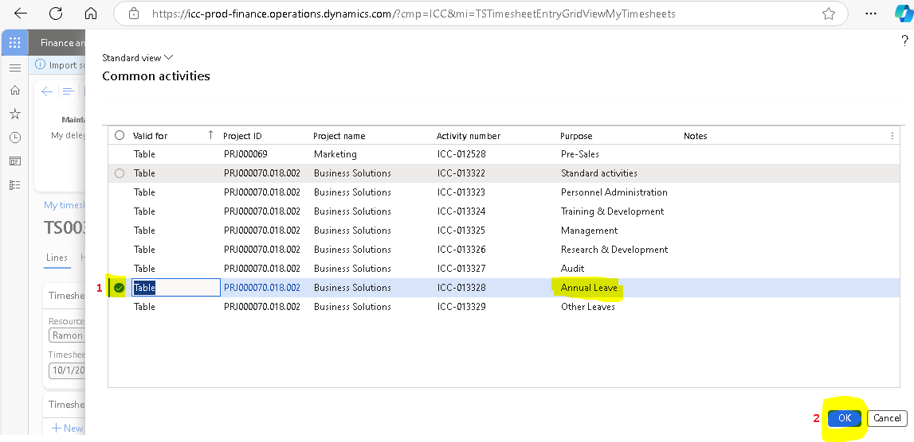

Input monthly hours.

Click “Input Time” to fill the time related to each selected activity.

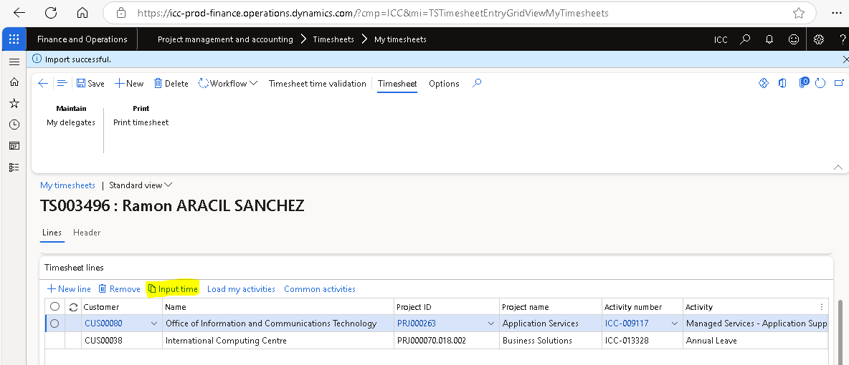

Within the column “Monthly Hours” fill the hours related to each activity. Then click “Register inputted time”

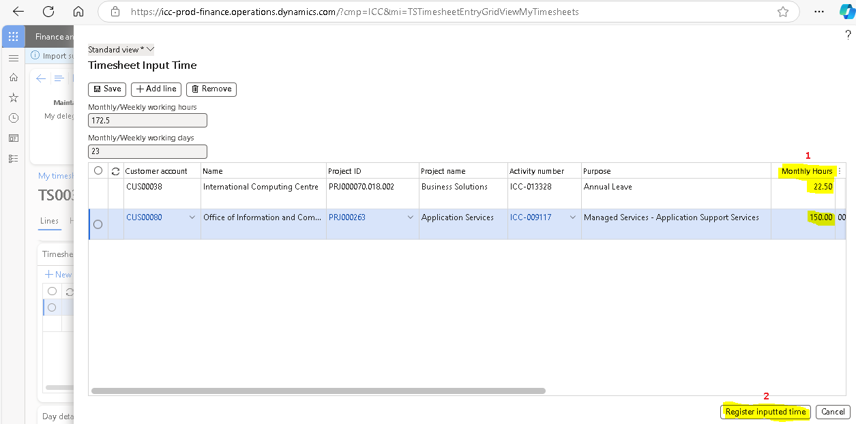

Check Timesheet hours matching Monthly hours (Staff only)

Check the hours registered in “Timesheet Total” corresponds with the ones in “Monthly/Weekly working hours”. This check is applicable to staff only.

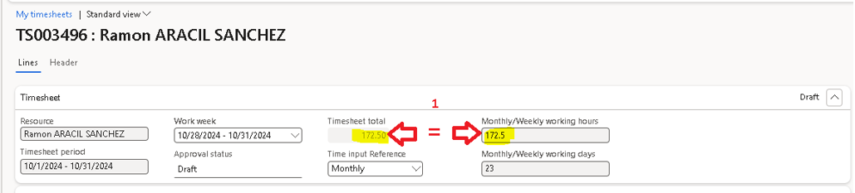

Register extra hours

Overtime (Staff Only)
Staff Members should first select the work week where the overtime occurred, then go to the OICT activity and fill the overtime hours in the specific day of the overtime activity.
Finally add “Internal comment” related to the overtime activity, then click “Save”.
You will notice that the hours registered in “Timesheet Total” may differ from the ones in “Monthly/Weekly working hours”. The difference is the overtime just registered.
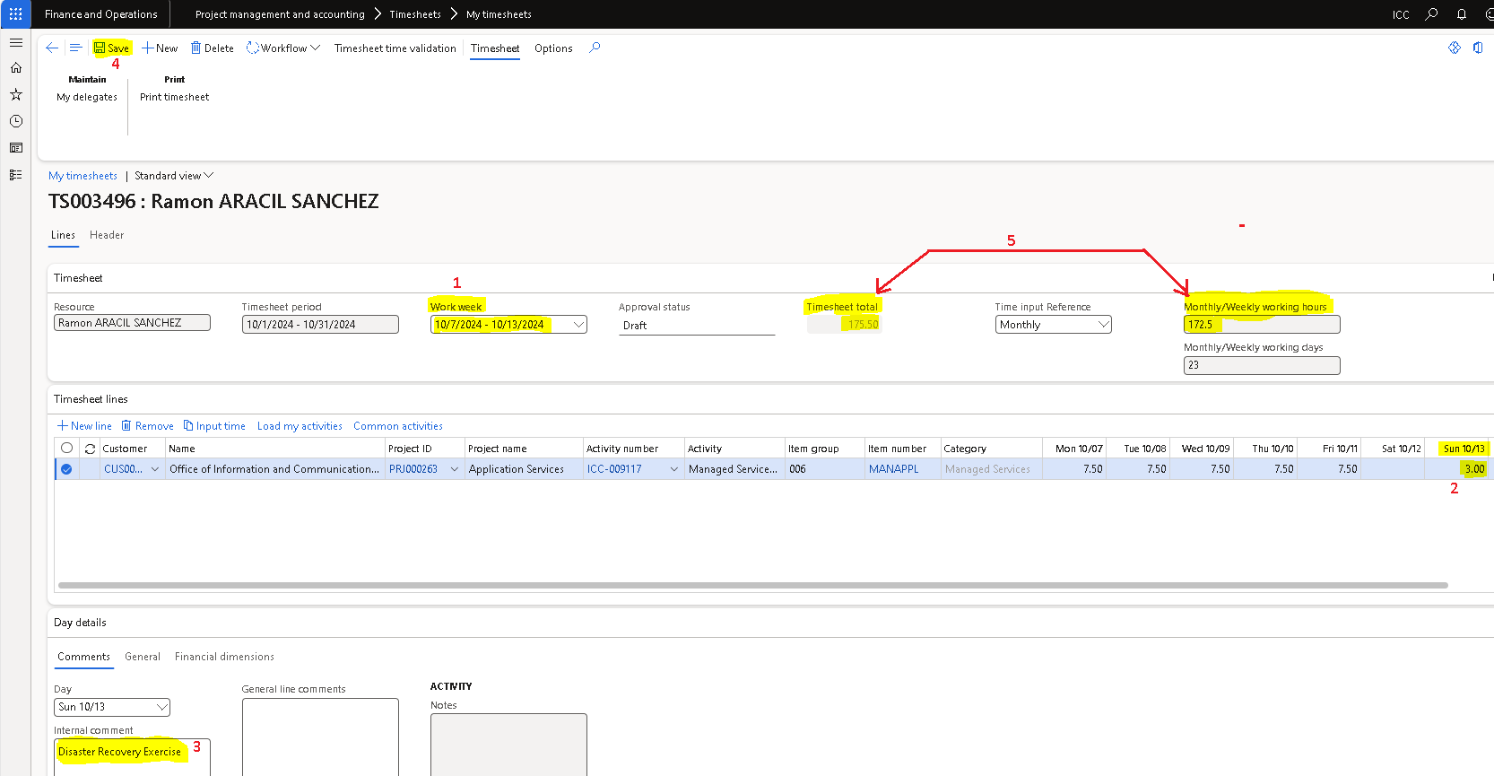

When clicking on “Timesheet time validation” you will observe a message indicating the number of hours exceeded that should correspond with the overtime registered, and a reminder to follow the corresponding overtime process in GSM.

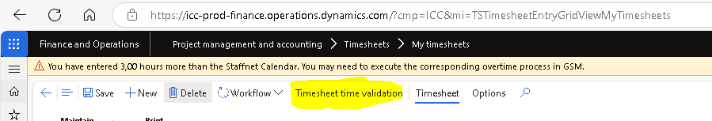

6.2 Register On-Call and Overtime (Consultants only)
Consultants should fill first the regular working hours related to the month in scope, as described in section 6 (Input monthly hours). “Timesheet total” field should initially reflect the total of regular working hours registered for a particular month.

However, if the consultant has performed Weekly Duty Officer activities during the month in scope, it should be registered as a separate line. Should proceed as follows:
- Make sure you select the proper “Work Week”
- click on “New line”
- copy the “Project ID” from the regular OICT record already filled in.
- expand “Activity Number” from the drop-down list.

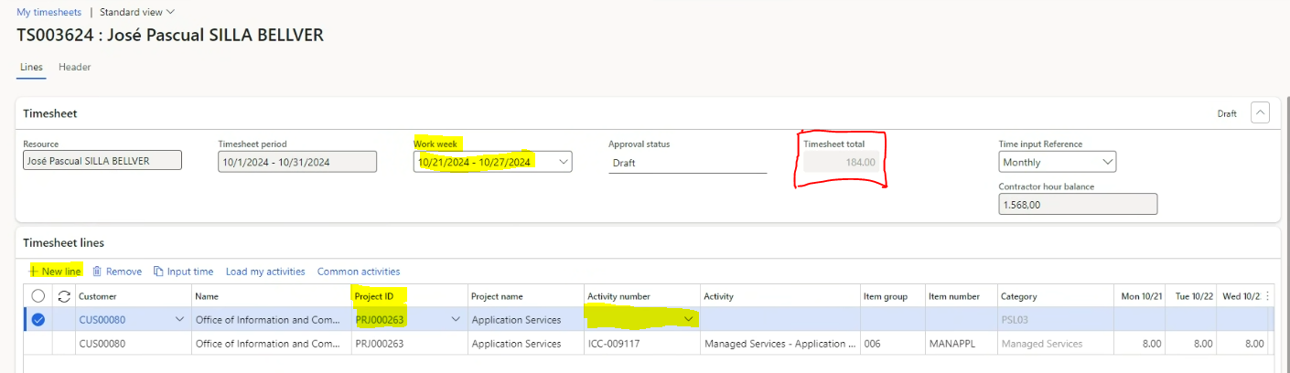
- Select the only option that appears when selecting “Activity Number”.
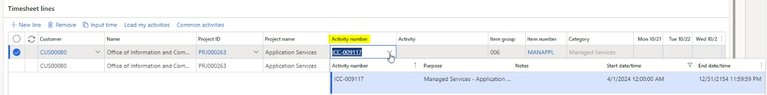
- Go to the right side and expand “Time recording type” drop-down list.
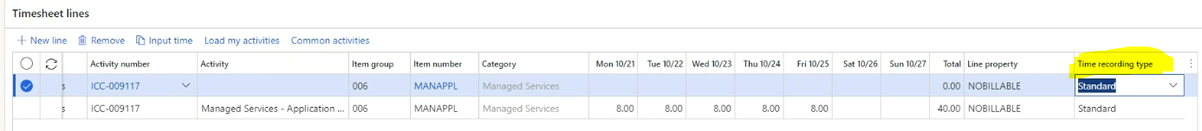
- Select “On-Call” for the Duty Call performed weekly by the consultant.
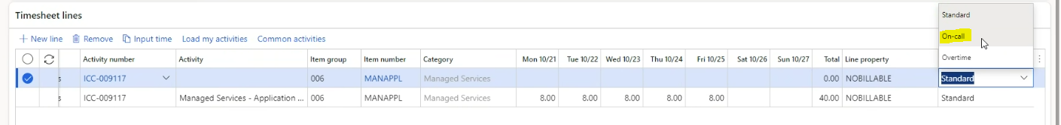
- Fill the weekly hours that consultant has in agreement (for example 2 hours)
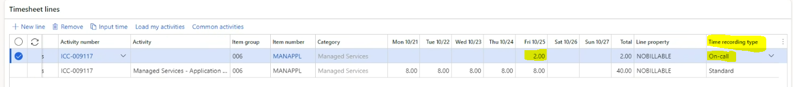
- Interventions should be registered in a new line as overtime (for example, 1 hour on Saturday)
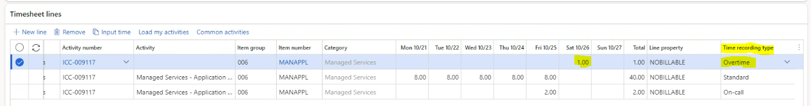

Once finished, click “Save” and press “Timesheet time validation”.
As a result, “Timesheet total” field reflects the total of working hours registered for a particular month. This includes not only regular working hours, but also on-call/overtime hours.
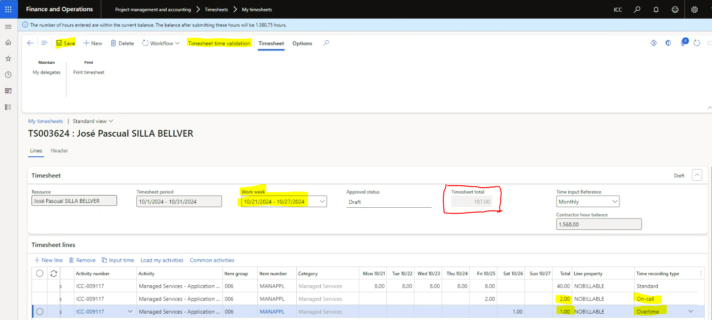

Confirm and submit monthly timesheet.

Once finished with the monthly timesheet, just click “Save”, “Workflow”, then click on “Submit”.

