The objectives should be aligned with Workplan – 2026 and training plan 2026.
This is a draft of AOM team Member SMART objectives for 2026 for your reference.
Please note that objectives #2 and #3 are same for all AOM. You can copy text from the file for those objectives. The Objective #1 is individual objective and should include projects / special activities that each of you participate in. For the big and important projects where you have significant role and contribution feel free to created separate additional objective. You should not have more than 5 objectives.

Objectives:
#1 SMART Objective
Individual objective – Major milestones or participation to key projects implementations
Example: Participate in the migration to Proxmox project for AOM related infrastructure.
List the projects/special activities that S/M participates

#2 SMART Objective
Operational & Service Excellence
- In line with the service delivery agreement, ensure levels of operational support meet or exceed agreed service level target
  - Resolution of Incidents WO on target no less than 95%
  - Resolution of RFS WO on target no less than 90%
  - Meet or exceed the targeted service availability (applications/DBs) and uptime of 99.90 % in all supported production components maintained and supported by the unit.
- Operate within the ISO 20000 framework
- Participate in “On Call” processes as per the unit schedule.

#3 SMART Objective
Compliance with AOM standards
- Time recording on a monthly basis before the end of the month
- Follow routine operation of service controls (Preventive maintenance plan)
- Tracking of Unite/Premier Support cases open by s/m
- Produce and update documentation related to supported services
- Operate and align to any changes of the UNICC and customer SMS

Competencies:
Beside mandatory competencies all AOM to include additional competency:
Moving forward in a changing environment.

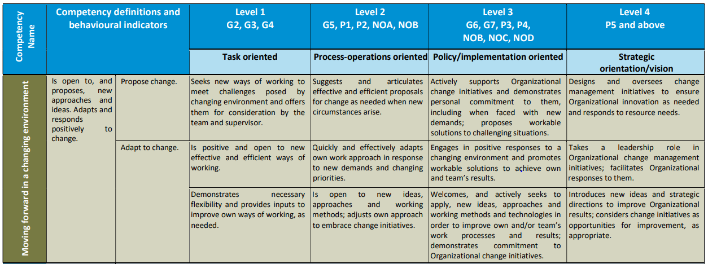

Learning and Development Plan
Learning and self-development to improve organizational knowledge and skills
- Participate in service management trainings and workshops provided by OPMX or customer Service Management team
- Participate in trainings organized by Learning Services Group, Microsoft Premier Support Workshops, or others
- Self-development using UNICC LinkedIn Learning, Microsoft Digital Training Academy, or other self-learning platforms
- Apply the Knowledge and concepts in ongoing projects and day-to-day support and management activities.

SMART Team Objective
Increase the AOM Unit versatility and capability in services provided by the Unit
- Participate in at least 3 internal knowledge transfer sessions arranged for all unit members.
- Each unit member produces at least one new step-by-step support procedure instruction document

