Contents
How to apply Windows updates on ArcGIS and Portal servers 2
Group 1, Group 2, Group 3, Group 4 2
Group 5 3
How to apply Windows updates on Geocortex servers 4
How to verify if the ArcGIS and Portal URLs are up and running 4
How to verify if the Geocortex URLs are up and running 7

How to apply Windows updates on ArcGIS and Portal servers

There are 6 groups of ArcGIS and Portal servers:
- Group 1 (Cluster: ags-p-app-01 and ags-p-app-02)- Nodes can be updated in different batches.
- Group 2 (Cluster: ags-p-app-05 and ags-p-app-06) - Nodes can be updated in different batches.
- Group 3 (Standalone servers: ags-p-app-07, ags-p-app-08, ags-p-app-09) - Servers can be updated in different batches.
- Group 4 (Cluster: ags-p-app-03 and ags-p-app-04) - Servers can be updated in different batches.
- Group 6 (Cluster: geopt-p-web-01, geopt-p-web-02)- Nodes need to be updated in the same batch.

Group 1, Group 2, Group 3, Group 4

- ags-p-app-01, ags-p-app-02
- ags-p-app-05, ags-p-app-06
- ags-p-app-07, ags-p-app-08, ags-p-app-09
- ags-p-app-03 and ags-p-app-04
Steps:
- Stop ArcGIS Server service on one node of the cluster or in the standalone server:
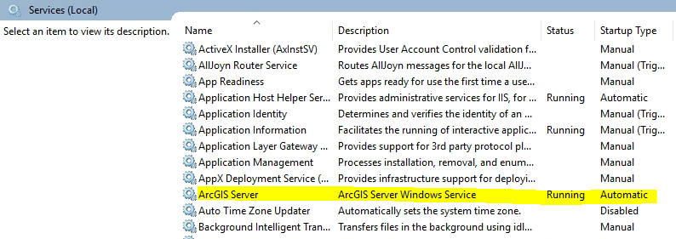
- Apply Windows updates and restart node\server if required.
- Verify that the ArcGIS Server service is running after restart node/server.

Group 5
- geopt-p-web-01, geopt-p-web-02
Steps:
  - Check the PRIMARY node on the below admin page (launch in private/incognito browser, uses AD authentication with UN login. Credentials-role access to be checked with GIS team)
https://geoportal.un.org/arcgis/portaladmin/machines

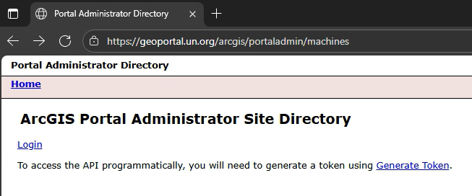

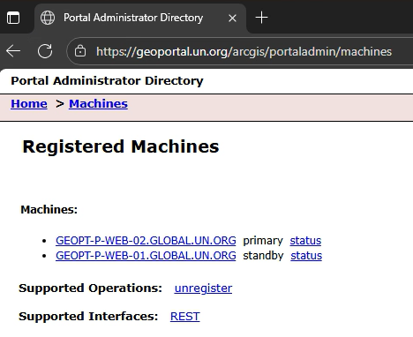

  - Ensure that on the STANDBY node the Portal for ArcGIS service has the Startup type configured as Manual (not Automatic) otherwise change it. The goal is not to trigger a failover process when we will stop on the service on the PRIMARY node.
  - Stop the Portal for ArcGIS service on the STANDBY node.

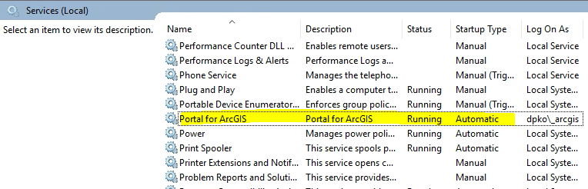
  - Install Windows updates on the STANDBY node and reboot the machine if required.
DO NOT start Portal for ArcGIS service.
  - Connect to the PRIMARY node and stop Portal for ArcGIS service.
  - Install Windows updates on the PRIMARY node and reboot it if required.
  - Verify that the Portal for ArcGIS service is running after restarting PRIMARY node.
  - Allow for 10-15 mins for the PRIMARY Portal for ArcGIS environment to come back online and test accessibility on the admin page.
  - Start again Portal for ArcGIS service also on the STANDBY node.
  - Configure back to Automatic the Startup type of the Portal for ArcGIS service.

How to apply Windows updates on Geocortex servers

There is 1 Geocortex cluster and for all nodes need to be updated in the same batch:
- Cluster
- geocx-p-web-04.global.un.org (manager)
- geocx-p-web-05.global.un.org
- geocx-p-web-06.global.un.org

Steps to be followed for both clusters:
- Stop Geocortex Core service on MANAGER node and wait 2-3 minutes.
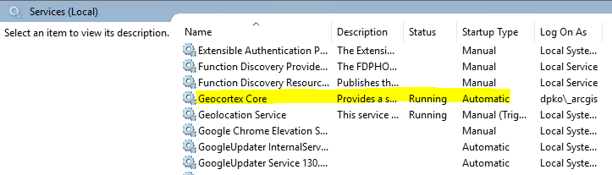
- Stop Geocortex Core service on the other 2 nodes.
- Perform Windows updates and server reboot on MANAGER node and wait 2-3 minutes.
Verify that the Geocortex Core service is running after restarting the node.
- Perform Windows updates and server reboot on the second node.
Verify that the Geocortex Core service is running after restarting the node.
- Perform Windows updates and server reboot on the third node.
Verify that the Geocortex Core service is running after restarting the node.

How to verify if the ArcGIS and Portal URLs are up and running

After the upgrade is completed, verify if the ArcGIS and Portal URLs are up and running:
NOTE: Use your @un.org account for log in.

https://geoportal.un.org >> (Cluster: geopt-p-web-01.global.un.org, geopt-p-web-02.global.un.org)
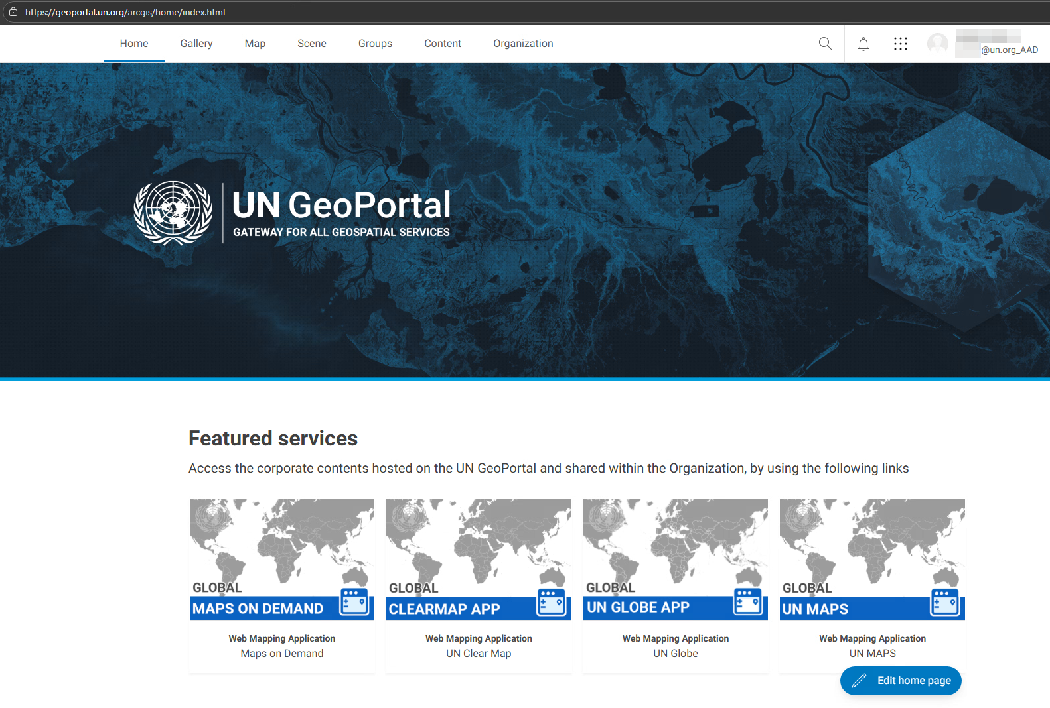

https://pro-ags1.dfs.un.org/arcgis/manager/ >> (Cluster: ags-p-app-01 and ags-p-app-02)
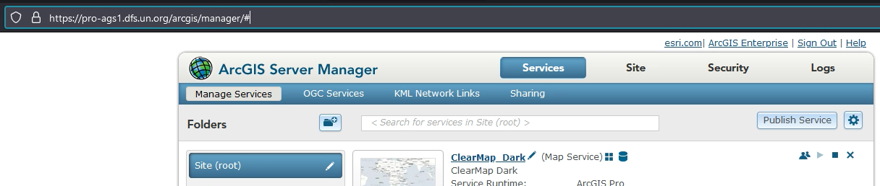

https://pro-ags2.dfs.un.org/arcgis/manager/ >> (Cluster: ags-p-app-03 and ags-p-app-04)
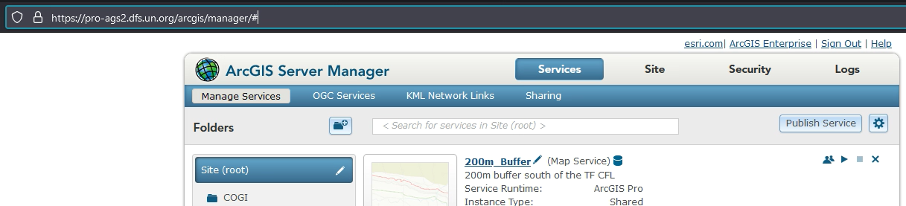

https://pro-ags3.dfs.un.org/arcgis/manager/ >> (Cluster: ags-p-app-05 and ags-p-app-06)
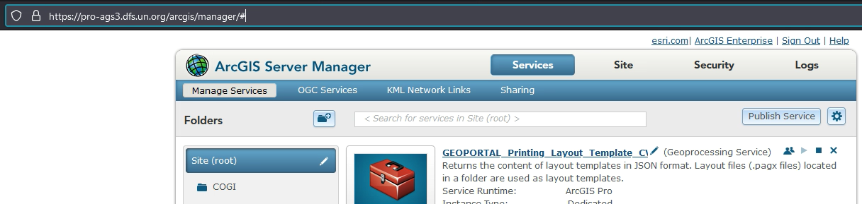

https://pro-ags4.dfs.un.org/arcgis/manager/ >> (Standalone server: ags-p-app-07)
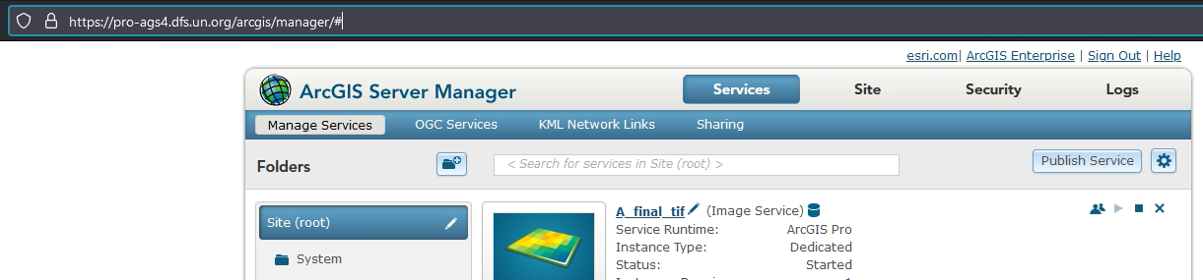

https://pro-ags5.dfs.un.org/arcgis/manager/ >> (Standalone server: ags-p-app-08)
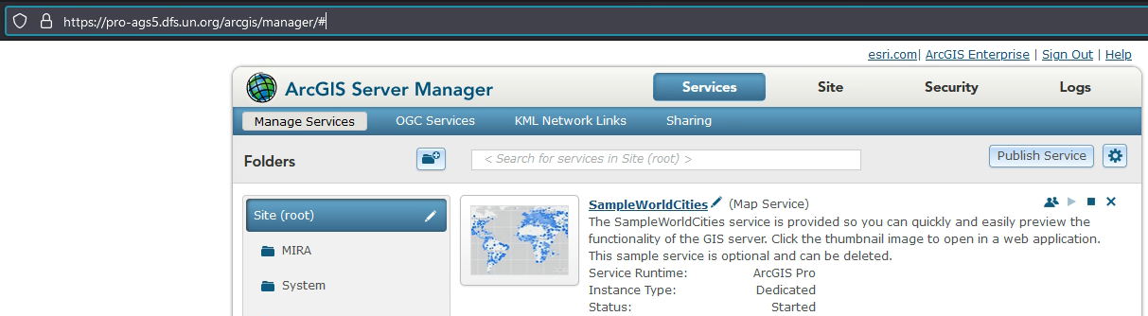
https://pro-ags6.dfs.un.org/arcgis/manager/ >> (Standalone server: ags-p-app-09)
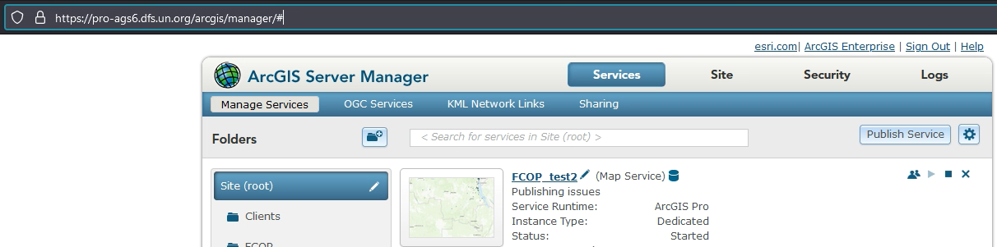

How to verify if the Geocortex URLs are up and running

https://maps.uniteaware.un.org/Geocortex/Essentials/RestManager/
- geocx-p-web-04.global.un.org (manager)
- geocx-p-web-05.global.un.org
- geocx-p-web-06.global.un.org

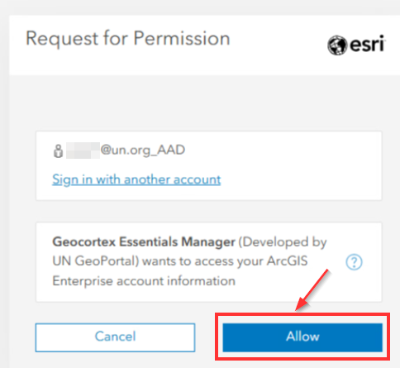
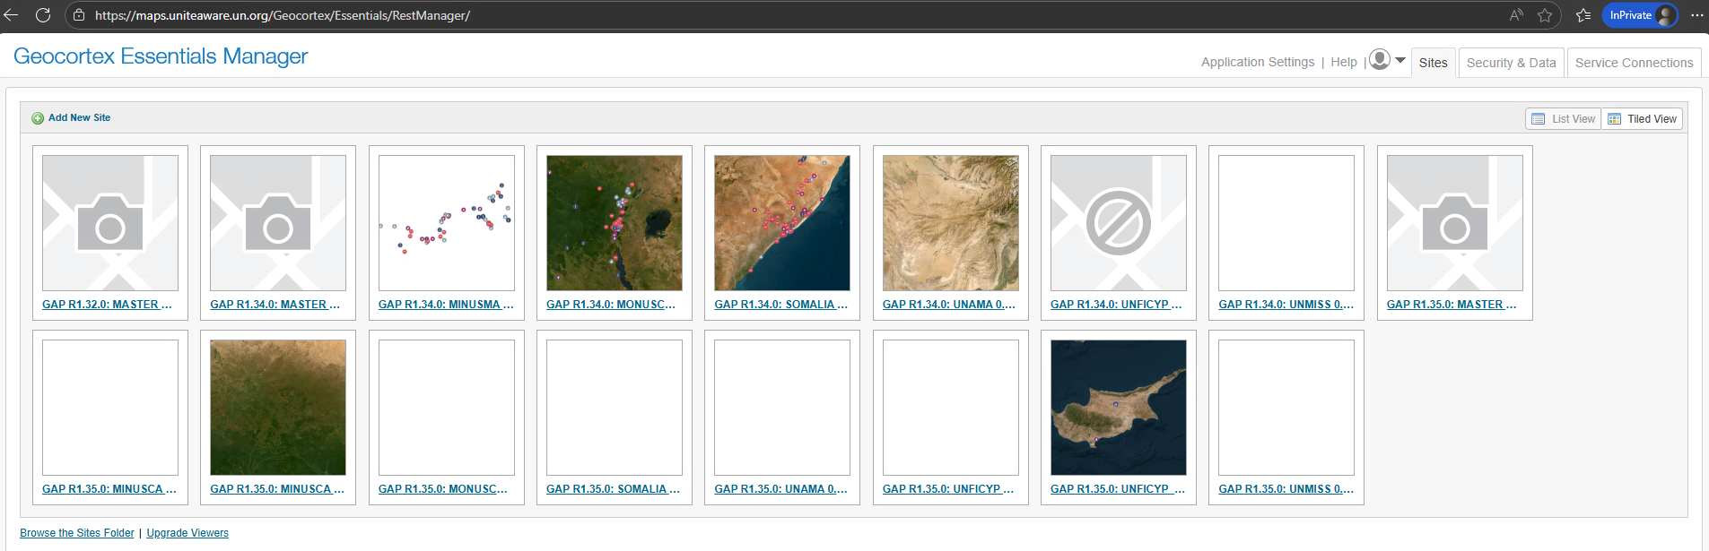

In case of any issues, please restart the related servers/ contact ASU APP team.

