Steps for Applying Windows Updates on OCHA OneGMS Servers

OCHA OneGMS server are:
- OCHA-P-APP-01.global.un.org
- OCHA-R-APP-01.global.un.org
How to check which server acts as Primary:
Ping the URL “onegms.unocha.org” and see which IP is returned…
If returned IP is 10.128.144.31 then OCHA-R-APP-01 is the PRIMARY
If returned IP is 10.128.16.31 then OCHA-P-APP-01 is the PRIMARY
Steps in case server to be updated is the Primary:
- Apply Windows updates and restart the server
- Check that all applications are started:
  - Connect to the server and open the IIS Manager
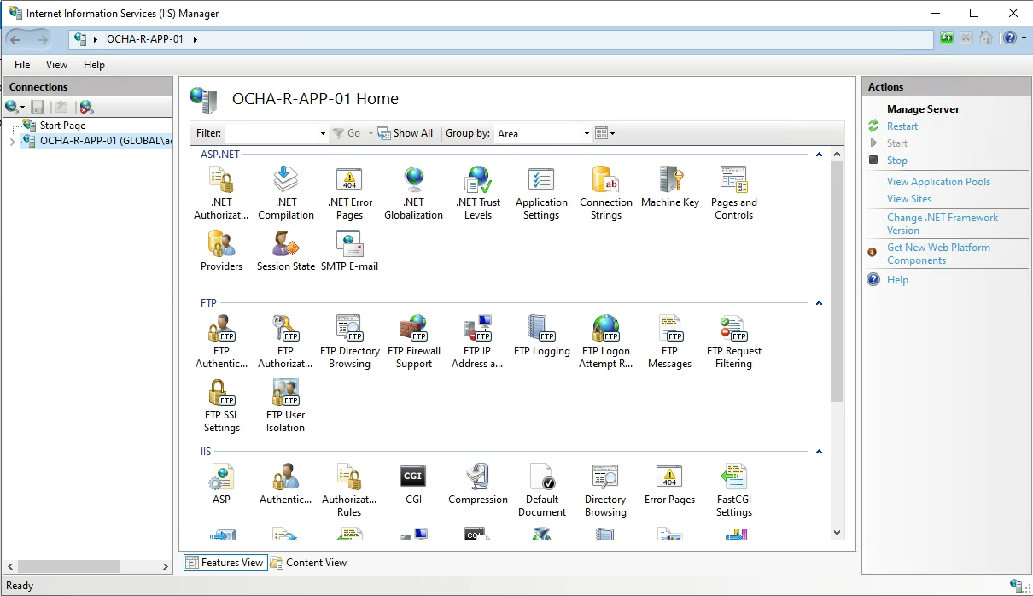

  - Expand the server and check that all Application Pools are started:
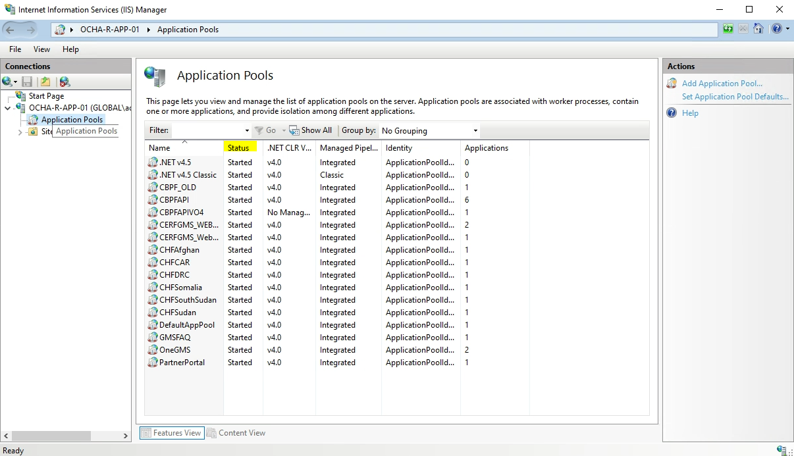

- Connect to the following URL and then click on the Login button: https://onegms.unocha.org/

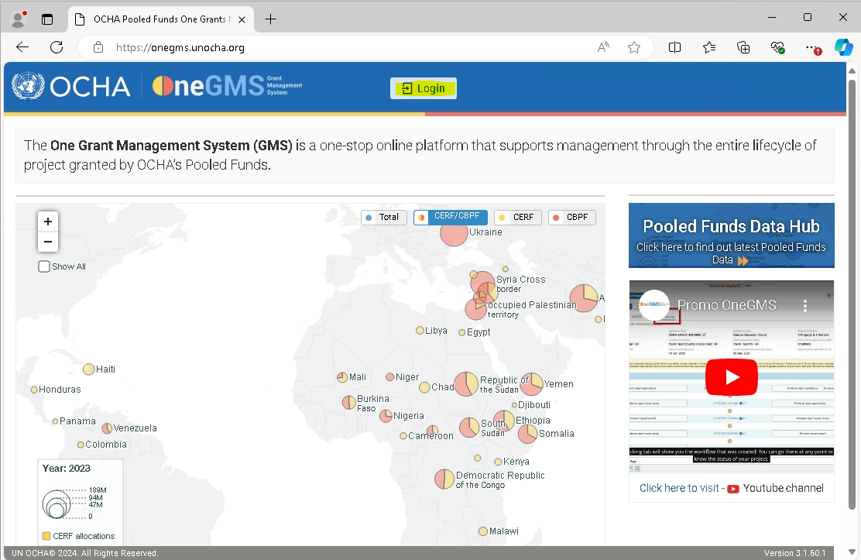

- Fill UN email and then click on Continue:
Email: ****@un.org
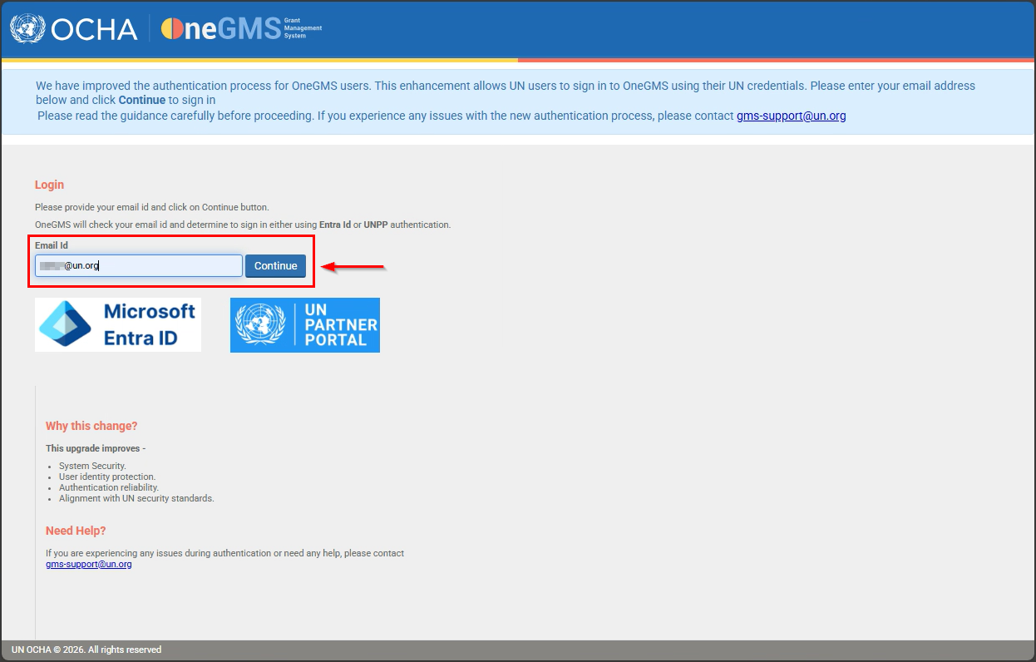

- In the next page, enter personal UN credentials (E-mail and Password):
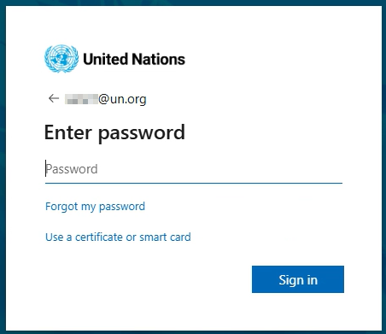

- If you see Edit Profile, this means that the application is working as expected. Click Fund Home and Logout.
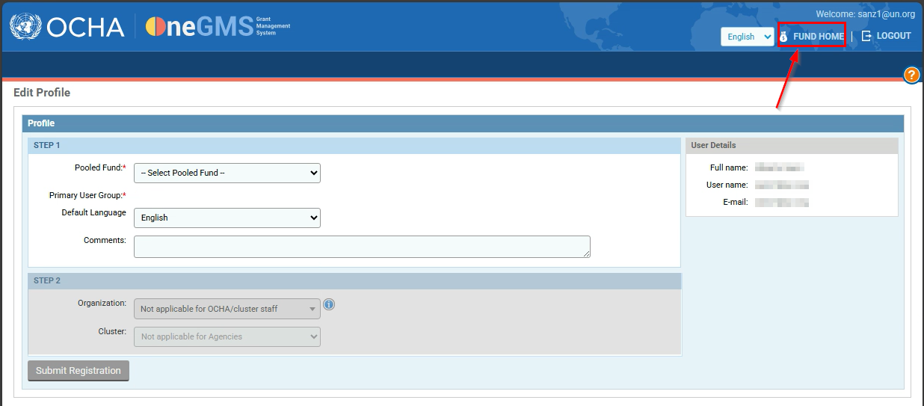
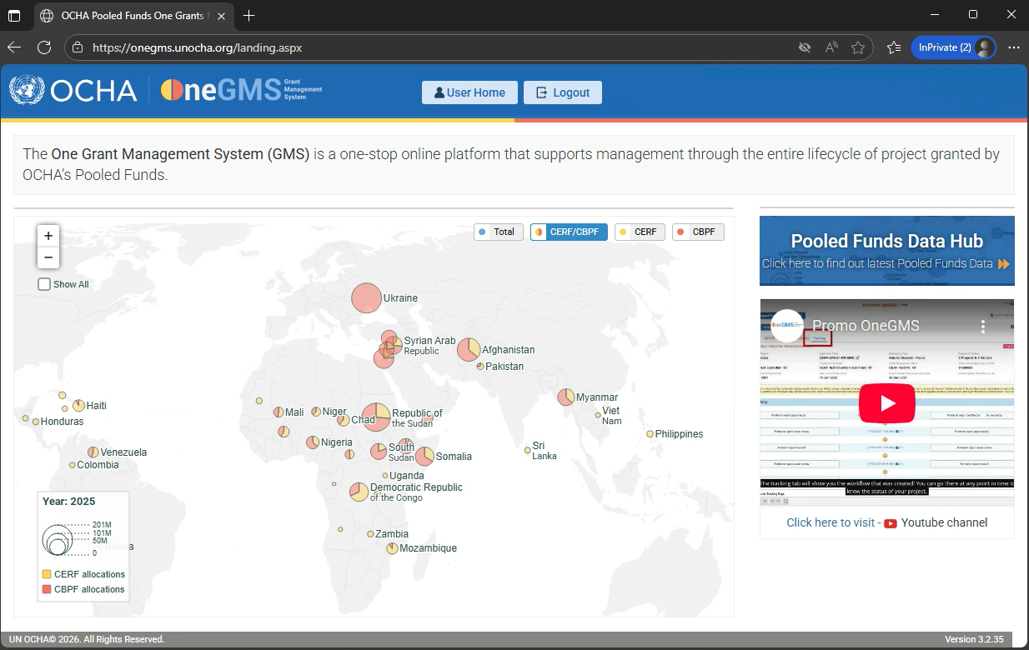

Steps in case server to be updated is NOT the Primary:
- Apply Windows updates and restart the server
- Check that all applications are started:
  - Connect to the server and open the IIS Manager
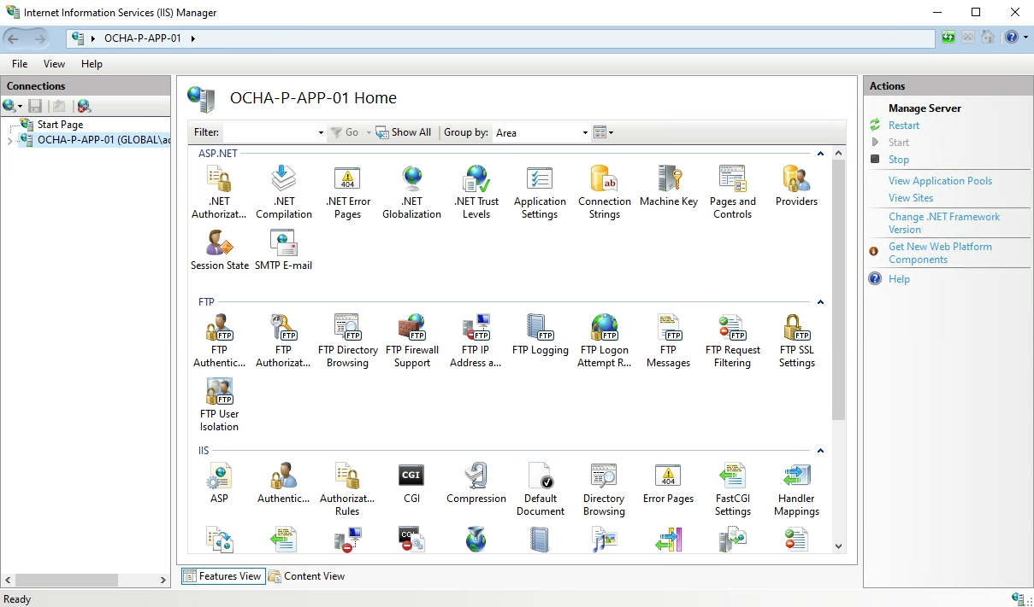
  - Expand the server and check that all Application Pools are started:
