Navigation Bar – v1.21

Table of Contents
1. Table of Contents 2
Purpose of this document 3
2. Front-end (Static files) 4
2.1 Copy the public files 4
2.2 Front-end deployment validation 4
2.2.1 Version check 4
2.2.2 Check navbar inclusion 4
2.3 Rollback 5
2.3.1 Version check 5

Purpose of this document

This document describes the procedure required for the INITIAL installation of the Navigation Bar Front-end in PRE & PROD.

Related “notifications platform” version
This version is related to the “notifications platform” version 1.1.7.
This module can be deployed before or after release 1.1.7 of the notifications platform. The order does not matter.

Front-end (Static files)

Copy the public files
Run as root:
- Backup the existing code
# mkdir -p /opt/www/backup && tar cvzSpf /opt/www/backup/$(date +%Y%m%d_%H%M)_navbar-fe.tar.gz -C /opt/www/navbar-fe .
- ADJUSTING THE ENVIRONMENT {env} in green (with values: pre/production)
- Delete the destination folder
  - # rm -rf /opt/www/navbar-fe/
- # mkdir -p /opt/www/navbar-fe/
- copy the file navbar-fe-code-{env}.tar.gz to /tmp/navbar-fe-code-{env}.tar.gz
- Extract the content of navbar -fe-code-{env}.tar.gz
  - # tar -xzvpf /tmp/navbar-fe-code-{env}.tar.gz -C /opt/www/navbar-fe/
- Adjust the permissions
  - # chown -R nginx:nginx /opt/www/navbar-fe
  - # chmod -R u=r,g=,o= /opt/www/navbar-fe/*
  - # find /opt/www/navbar-fe -type d -exec chmod u=rx {} \;

Front-end deployment validation

Version check
Open the following URL in any browser (press Ctrl+F5 to full refresh):
PRE: https://pre-comms.uniteaware.un.org/navbar/version.json
PROD: https://comms.uniteaware.un.org/navbar/version.json

They must show the current version of the Navigation Bar:
{
"version": "1.21"
}

Check navbar inclusion
PRE: https://pre-comms.uniteaware.un.org/navbar/navbar-inclusion.html
PROD: https:// comms.uniteaware.un.org/navbar/navbar-inclusion.html
The result must be an empty page with the text “Basic Navigation Bar inclusion page” and the NavBar at the top of the page (showing the “Log in” button or the logged-in user depending on whether the user is logged or not in Azure).

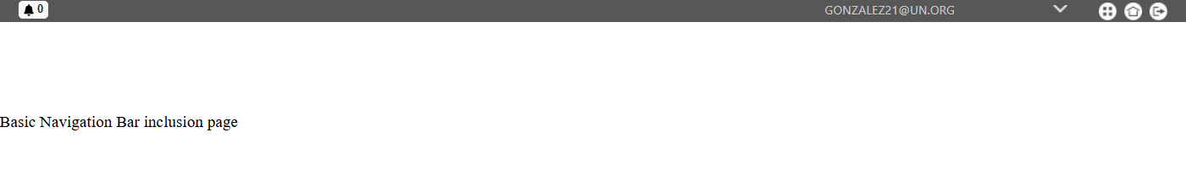

Rollback
If there is some error, this is the rollback procedure.
Run as root:
- Delete the destination folder
  - # rm -rf /opt/www/navbar-fe/
- # mkdir -p /opt/www/navbar-fe/
- Extract the content ({anydate&time} is any suffix with date & time format)
  - # tar -xzvpf /opt/www/backup/{anydate&time}_navbar-fe.tar.gz -C /opt/www/navbar-fe/
- Adjust the permissions
  - # chown -R nginx:nginx /opt/www/navbar-fe
  - # chmod -R u=r,g=,o= /opt/www/navbar-fe/*
  - # find /opt/www/navbar-fe -type d -exec chmod u=rx {} \;

Version check
Open the following URL in any browser (press Ctrl+F5 to full refresh):

PRE: https://pre-comms.uniteaware.un.org/navbar/version.json
PROD: https://comms.uniteaware.un.org/navbar/version.json

They must show the current version of the Navigation Bar:
{
"version": "1.20"
}

